What motor specs do I need?

1. Determine needed torque

Torque = Force (F) \* Moment Arm (r) \* sin(Θ)

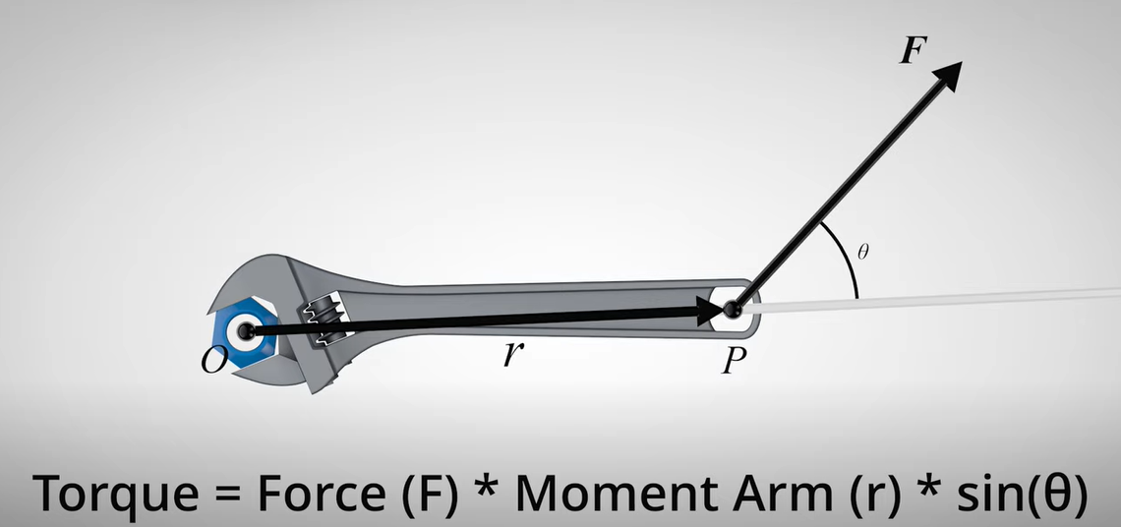

Figure 1: Torque

F= .09 \*10^3 N (N = kg\*m/s2)

r = 0.01905m

Θ = 90

T ≈1.53 Nm

1. Determine needed precision
2. Potential motors
   1. <https://www.mouser.com/ProductDetail/SparkFun/ROB-09238?qs=WyAARYrbSnaueIRDnnTgzg%3D%3D&mgh=1&gclid=CjwKCAiA4KaRBhBdEiwAZi1zzhK-wqfjedTVfnr_fU8ranzGH34iWvmLSNvftWO2YgFD-29hdX7_ehoCX14QAvD_BwE>

Resources:

* <https://www.unitconverters.net/energy/newton-meter-to-inch-ounce.htm>